**Project Team 5**

Matthew Bertello, Evan Halverson, Michael Hulbert, Michael Meisenburg

Our team currently uses discord to communicate, and we meet every Tuesday and Thursday starting at 6:30 pm (depending on group member availability). These meetings will review team progress, brainstorm and collaborate to solve coding and project problems, and will provide the team with a team bonding opportunity. The team or a team representative will update our project stakeholder every two weeks to review progress and acquire feedback.

**Psychology Test Review App (Preferred)**

The goal of this project is to create an app that will help students improve their grades by giving them an easy tool to generate practice problems that will help them study for an exam. The app will be able to generate randomized practice problems, recognize correct/incorrect answers, and give immediate feedback.

**Motivation**

The motivation is to help students improve their grades by giving them an easy tool to have practice problems that will help them study for exams and quizzes.

**Core Functionality**

The instructor should be able to generate practice problems, create questions (such as multiple choice or fill in the blank), give the students access to the created practice problems, and see details of the overall performance of the students.

Students should be able to access the practice problems made by the instructor, answer the questions with provided feedback, give their own feedback or ask questions, and view class average stats.

**Screen Mock-Ups**

Introduction and Review Question Specification

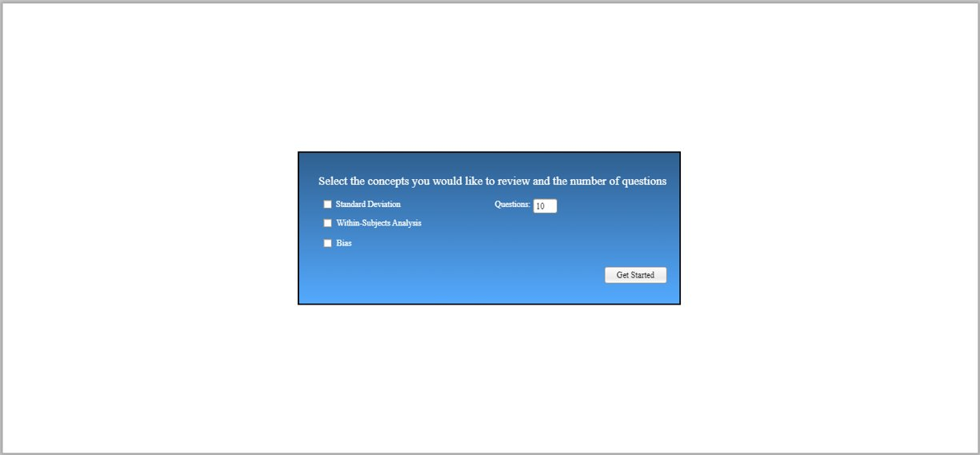

Fill-in the Blank Questions (Wrong Answer)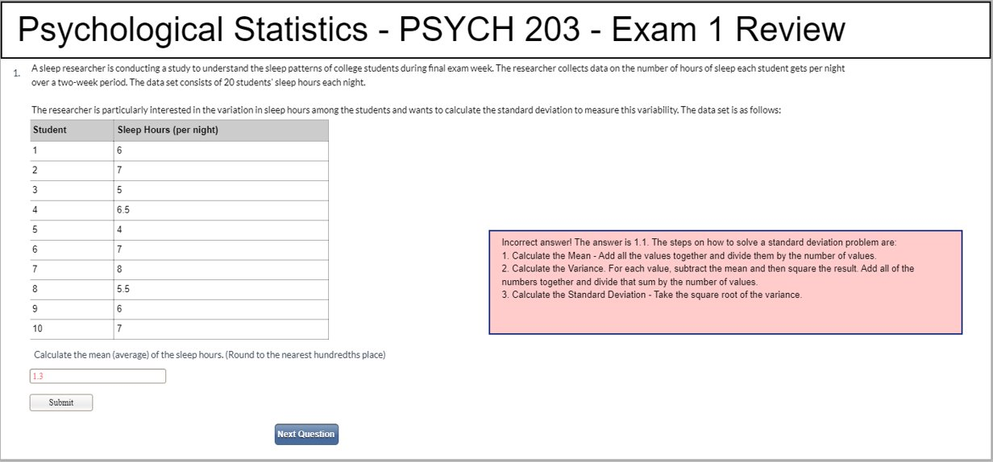

Fill-in the Blank Questions (Correct Answer)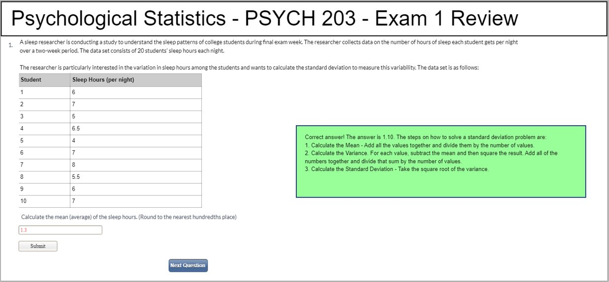

Summary Information

**Admissions Counselor Scheduler App**

The goal of this project is to create an app that will assist the admissions personnel to schedule individuals to give presentations. It will have a user-friendly interface that will allow users to enter in their availability preferences and presentation times and will generate a schedule that meets the given constraints.

**Motivation**:

The motivation for the Admissions Counselor schedule App is to make it easier to schedule presenters for events while accommodating individual availability preferences and to make it easier to view the presentation schedule. This will assist the employee’s work-life balance.

**Core Functionality**

Users (the admissions office) should be able to access their own account (what counselor is currently using the app) view all needed appointments, edit their own availability and preferred time, and add / remove all events.

Should be able to auto-generate a best-fit-case for schedules optimizing times for each administrator and when their appointments should be.

The user availability preferences and events will be stored in a database. This information will then be used to generate a schedule that meets the constraints given by the user preferences that ensures that all events are scheduled for.

**Screen Mock-Ups**

Home Page (Main View)

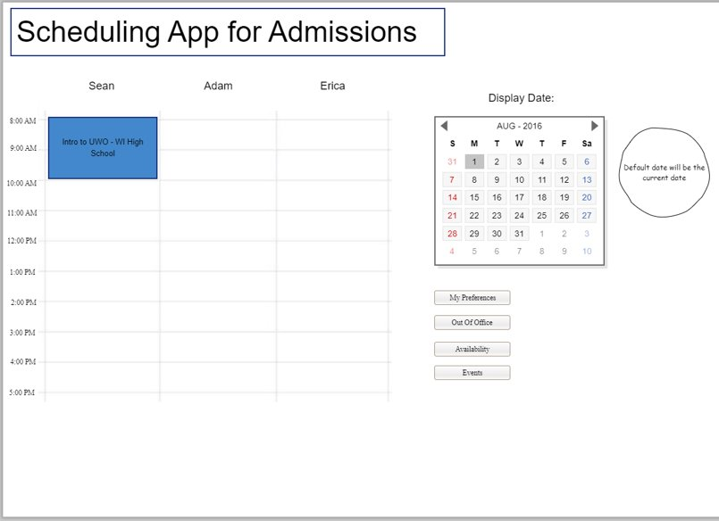

Edit Preferences

Edit Out Of Office

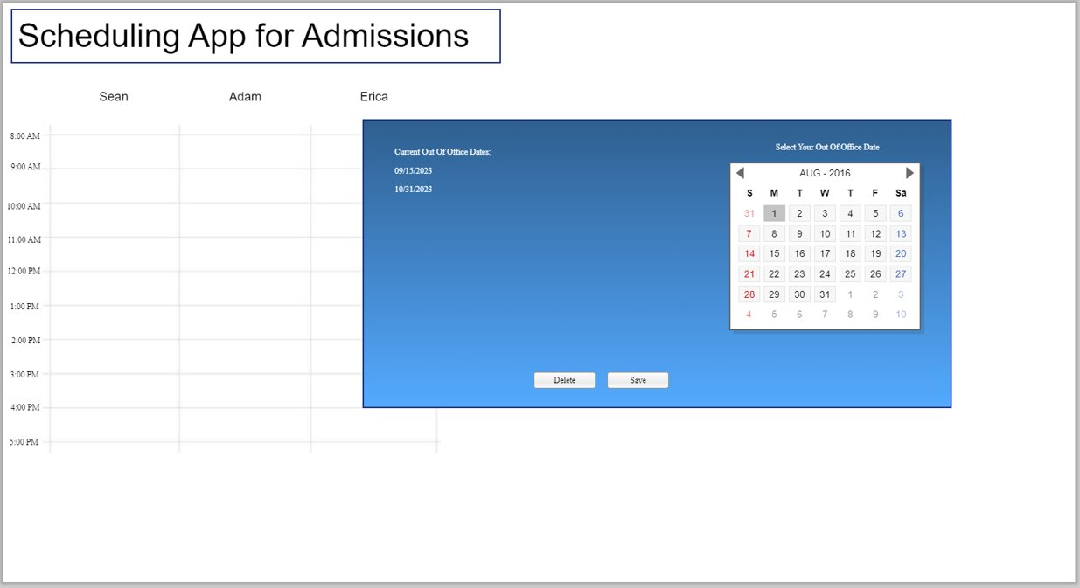

*The blue box will pop up and out of the home page screen.

Edit Available Hours

Edit Events

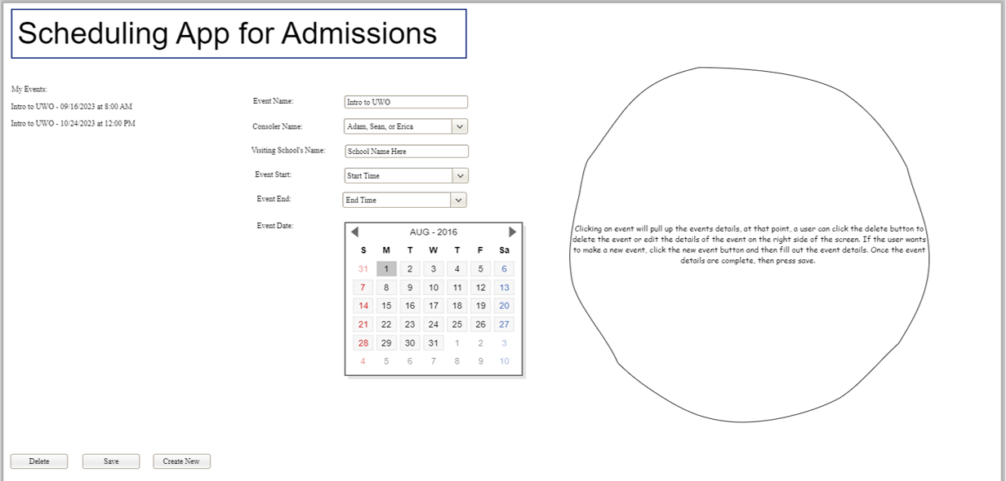

*The white circle is a tool tip.